**Project Development Phase**

**Sprint – 1**

|  |  |
| --- | --- |
| Date | 9 November 2022 |
| Team ID | PNT2022TMID18041 |
| Project Name | Hazardous Area Monitoring for Industrial Plant powered by IoT |
| Maximum Marks |  |

**Task:**

Obtain the sensed data and visualize it in Node-RED.

**Steps:**

1. IBM IoT node is used to gather sensor data and the necessary API key is provided to establish connection.
2. Using functions namely Temperature, the data is obtained independently and displayed in dashboard.
3. Dashboard Nodes are used to display the sensed data to the user in a portal.

**Codes for functions:**

Temperature - msg.payload = msg.payload.temp

return msg;

**Output:**

1. **Data from Node-RED**

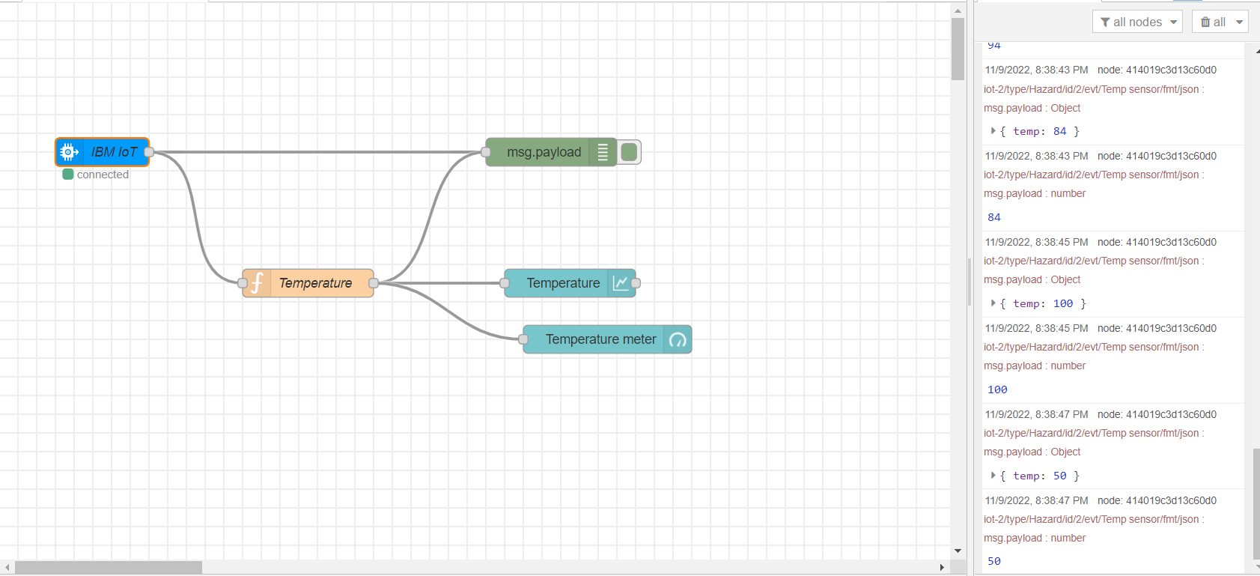

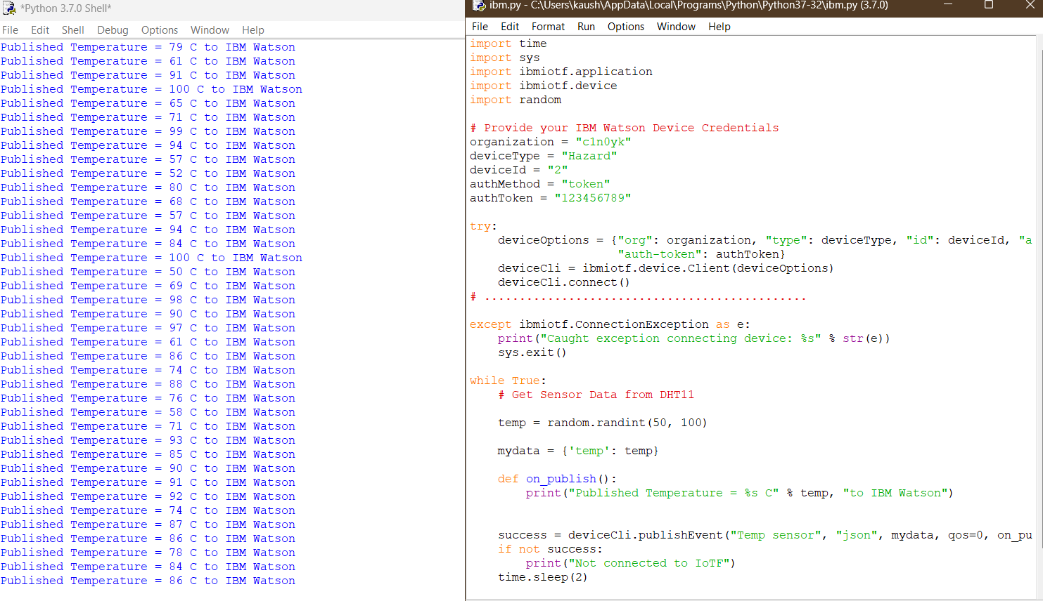

1. **Data displayed in dashboard.**

